UNITED SCIENTIFIC SUPPLIES, INC.
OPERATION AND EXPERIMENT GUIDE

ZEEMAN EFFECT APPARATUS

ZEA001

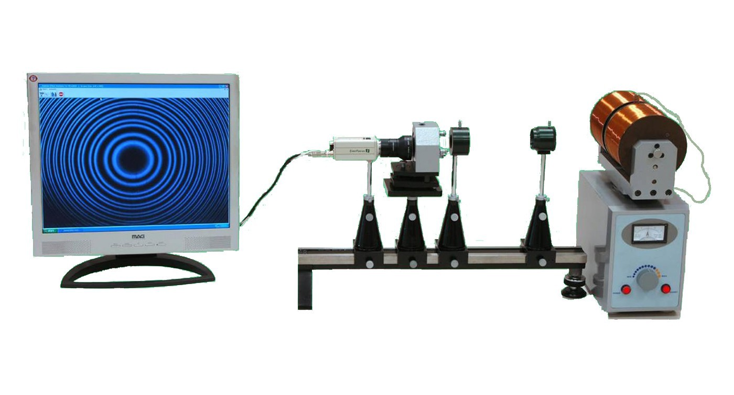
1. Introduction
This apparatus was designed for modern physics labs at universities and colleges. It demonstrates
the influence of a magnetic field on light emitted in a gas discharge, the Zeeman Effect, and shows the quantum nature of light and the behavior of electrons in atoms emitting light. Using the software supplied with the apparatus, students can collect data and analyze it to determine the value of e/m for bound electrons in an atom. A mercury discharge lamp is placed between the pole pieces of a powerful electromagnet and the green emission line at 546.1 nm is selected by an interference filter. The resulting light beam is passed to a high resolution, fixed separation Fabry-Pérot étalon whose
interference pattern is captured by a CCD camera and passed to a computer, where special software analyzes the changes observed as the magnetic field is varied. Light can be observed both parallel and transverse to the magnetic field, and filters allow the polarization states of the emitted lines to be investigated. The Fabry-Pérot étalon can also be used for other experiments requiring high resolution spectroscopy.

The determination of e/m from optical measurements requires the student to be familiar with optics, electromagnetism and quantum physics. The design of this Zeeman Effect Apparatus, integrating the optical, imaging and computer analysis features, makes it much easier to use than traditional Zeeman Effect setups and requires less demanding measuring skills, allowing students to focus more on the underlying physical principles of the phenomena being observed.

Zeeman Effect Outline (Revised Fall 2014)
- Purpose: A) Demonstrate Zeeman Effect B) Use Zeeman Effect to measure e/m for electron.
- Background Reading: See pages 4-5 below. You can also read about it in Melissinos book in cabinet. Look up operation of Fabry-Perot Interferometer on Internet. Note to instructor: Card and software are on computer labeled Zen 15.
- Some changes have been made since the company first sold this equipment. In particular the camera is different from that shown in cover picture. Learn how to use the camera. There is not much to do. You don’t even have to record using camera memory. A page identifying the camera parts will be provided separately. The complete instruction manual is stored in the Zeeman Effect folder.
- Turn on the computer and create a folder in the Temp folder to store your images. Use your names as part of folder name. Some examples of what to look for are in the Zeeman Examples folder. One of them shows what happens if there is too much room light. When saving image turn off lights above apparatus. If this is not enough the parts on the optical bench will need to be covered when saving image.
- See Care of Apparatus on page 13. Then set up optical parts. See sections 4-6 in manual for starting positions. You probably will not have to move the parts along the optical bench once they are setup but you will have to adjust the heights of the 4 devices. Start with the edge of the magnet yoke about 15 cm from the lens/polarizer. Adjust the red dot on the polarizer to 45 deg. Adjust the position of the Fabry-Perot interferometer so the two legs are in the second groove from the right.
- Temporarily remove the camera. Turn on the magnet power supply. Turn on mercury lamp power supply. The original mercury tube has been replaced by one connected to a separate power supply. There is a delay before it comes to full brightness. Do not look at tube w/o UV absorbing glasses. If needed move the optical bench so small Mercury light source is in line with optical bench. Look through the Fabry-Perot interferometer. Move you head around until you see a ring pattern. Adjust the vertical and horizontal knobs and move interferometer toward or away from the wall until ring pattern is close to centered. Adjust the height of the polaroid/lens combination for brightest image.
- Click on the Zeeman Effect icon to start image capture and analysis program.
- Put the camera in place and plug in the adapter. Turn on the camera and adjust camera and optical parts so you are seeing the ring pattern. Some additional adjustment may be needed later.
- Connect cable from computer into camera. Click on camera icon on program display. You should see a fuzzy pattern. Use Action menu to select correct settings. See pages 14-15 for details. If you get an error message close program and try again. See lab administrator if problem persists.
- Adjust camera and optical parts as needed to try to get 4 complete rings. This involves a certain amount of trial and error. See example in Zeeman examples folder.
- Once you have the ring pattern save the image (bitmap or jpeg). See section 7 before proceeding. Turn on the magnet. Observe what happens as you increase the field. Save image for maximum current (~1.5A). Return the current to lowest setting. Turn the polarizer to 0 deg. Observe and describe what happens as you increase the current. Which component are you seeing (see background material)? Save image for maximum current. Observe and describe what happens when you change the polarizer to 90 deg. Save image for maximum current.
- The rings you see with polarizer at 90 deg are actually made up of 3 rings (pi components). To see structure proceed as described in step 13.
- Move the optical bench so the edge of magnet yoke is about 5cm from the lens/polarizer. You will have to use only partial rings for analysis. Adjust so you are seeing half a circle for smallest ring. Turn on the magnet and adjust for max current. If you do not see the 3 parts try adjusting the focus. If the focus keeps changing see instructions about switching camera to manual and using manual focus. Look at examples in Zeeman Examples folder. If you cannot see the 3 components call instructor.
- Once you have a good image save it. You need to have enough of the smallest ring so that the center of the circle you will draw is in the display area. Turn off mercury tube power supply. Carefully remove the small Mercury tube so you can measure the magnet field using the gaussmeter. The field will be around 1 Tesla. Return tube to position between poles. Turn down magnet current all the way while analyzing.
- Analyze the image as described below. See pages 15-18 for computer analysis. If you get an error message when you try to draw the circles, get another image and try it. See instructor if problem persists. Record the value of e/m. See sections 8 &9 for the theory behind the computer analysis.
- Once you have gotten the 90 degree image analyzed do the observations described on page 19. The quarter wave plate (Fig. 11b) is in box labeled Zeeman. Save images. Return pole piece to magnet when finished.
- Rotate magnet back to position you started with. Get additional images like the one you got in steps 12-14 as time permits (try to get 10). Try varying the magnet current and focus. Turn polarizer a few degrees each way. Turn down current between measurements. Leave the mercury tube on until you are finished getting images. Turn off power supplies, computer and camera when finished for the day.
- Analyze additional images. If you are working with a partner split the analysis work.
- Computer average value of e/m and compare to “book value” The display leaves off some powers of ten. Compute the standard deviation.
- Make copies of your images for your report or notebook. One way to do this is to open the image file and use print screen to transfer image to MS Word document and print.

2. Specifications

Lamp: Mercury discharge lamp, slim design, powered A.C., 1500Vp-p, 5W Observed emission line: 3S1 (6s7s) → 5P2 (6s7s) at 546.1 nm

Electromagnet: Built-in current-controlled power supply, 90V DC, 0-5 – 1.4 A, with analog ammeter
Magnet rotatable 90° for transverse or longitudinal viewing
Maximum magnetic field at lamp position: 1.3 T

Fabry-Pérot Etalon: Aperture: 40 mm
Separation of quartz plates: 2.0 mm Central wavelength: 589.3 nm Resolution λ/δλ: ≥2 x 105
High reflection bandwidth: 100 nm

Interference Filter: Central wavelength: 546.1 nm Transmission bandwidth: ≤ 10 nm Peak transmission: ≥50%

Collimating Lens: Aperture: 37 mm
Focal length: 110 mm

CCD Camera: Sensor: Sony 1/3‖ HD CCD sensor (black/white)
Pixels (CCIR): 752 x 582
Horizontal scan resolution: 600 lines
Minimum detectable illumination: 0.1 Lx at f/1.2
Signal/noise ratio: > 48 dB
Automatic Electronic Shutter (AES): 1/60s – 1/100,000s (NTSC) Automatic Iris Control (AIC): Video Drive and DC Drive supported Gamma: 0.45
Lens Mount: C and CS supported Automatic Gain Control: Yes Automatic White Balance: Yes Backlight Compensation: On/Off Synchronization: Internal, negative
Video output: 1Vp-p into 75 Ω, BNC connector
Input voltage: 12V DC
Power consumption: 1.65W

Environmental: Operating limits: 0 - 40° C (32 - 104°F), relative humidity ≤ 85% Choose a location free from vibration or electromagnetic interference

Power Input: 110VAC/60 Hz, 190W

3. Basic Theory
When a light-emitting atom is subjected to a magnetic field, its emission lines are
split into multiple components at slightly shifted wavelengths. This phenomenon is known as the Zeeman Effect, named for Pieter Zeeman, who first observed the phenomenon in 1896 in Leyden (Netherlands), and received the 1902 Nobel Prize in Physics for his discovery.

The atomic magnetic moments along a given axis are quantized, and assume defined orientations when subjected to a magnetic field. In these orientations, the atoms’ bound electrons have different energies than in the zero-field state, the amount of the difference depending on which of the several allowed orientations an electron assumes. Each energy level is therefore now split into several sub-
levels, and light-emitting transitions between levels which were all of the same energy at zero field regardless of the electron orientation have now become a series of different, orientation-dependent transitions at slightly differing energies. This is experienced as a splitting of the observed spectral line on imposing a magnetic field.

The transitions which can be observed in a magnetic field are governed by the selection rule for the magnetic quantum number M, namely that for allowed transitions ΔM = 0 or ±1, and also by the state of polarization of the emitted light. Linearly polarized light is observed in a direction transverse to the magnetic field, while circularly polarized light is emitted parallel to the field.

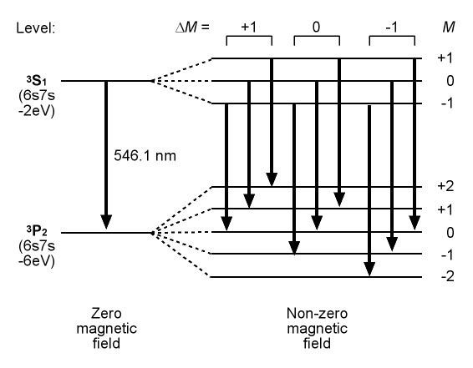
In this apparatus, the spectral line observed is the green line of mercury at 546.1 nm, which splits into nine compo- nents (see Figure 1). The distribution of the observable lines in a magnetic field is shown in Table 1.

ΔM | Perpendicular to Field | Parallel to Field
+1 | Linearly polarized  – σ+ | Circularly polarized  – σ+
0 | Linearly polarized  – π | No light
-1 | Linearly polarized  – σ- | Circularly polarized  – σ-

Table 1 Figure 1
Figure 1

When the lines are observed perpendicular to the magnetic field direction, all nine components will
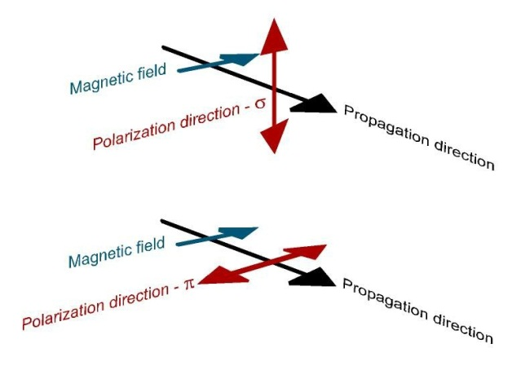
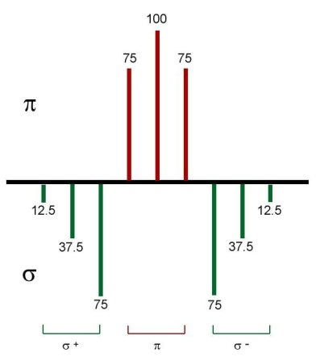
be visible. They include three π polarized lines and six σ polarized ones. The polarizations arise from the relative orientations of the magnetic field and the vibration directions of the emitted light, as illustrated by Figure 2:

Figure 2 Figure 3

The three π lines are located in the center of the pattern and are the most intense. The six σ lines are weaker and located on the outside of the pattern. Figure 3 illustrates this arrangement. Overlapping of the closely spaced lines makes observation and measurement difficult. However, since all the lines are linearly polarized, a polarizing filter can be used to block the six σ lines, leaving the three central π lines more clearly visible for measurement. Rotation of the filter enables the existence and polarization state of the six σ lines to be confirmed.

4. The Zeeman Effect Apparatus
Figure 4 shows the arrangement of the components of the Zeeman Effect Apparatus.

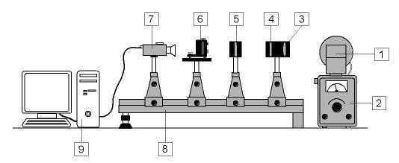
Figure 4

1 Magnet with Mercury Lamp 6 Fabry-Pérot Etalon
2 Magnet Power Supply 7 CCD Camera
3 Focusing Lens 8 Optical Bench with Riders
4 Polarization Filter 9 Computer with Capture Card
5 Interference Filter

The slim, low pressure mercury lamp is mounted in a support at the center of the poles of the electromagnet (1), whose yoke can be rotated 90° on top of the magnet power supply (2), which also energizes the mercury lamp. Light from the lamp is focused by a lens (3) and passes successively through a rotatable polarization filter (4) and an interference filter (5), which selects the green line at
546.1nm, before falling on a Fabry-Pérot étalon (6). The étalon generates an interference pattern of concentric rings which is observed by a CCD camera (7). The optical elements (3) through (7) are mounted on an optical bench (8) for easy adjustment; careful alignment of the optical arrangement significantly improves the interference pattern and the accuracy of the results. The signal
from the CCD camera is passed to a capture card in a computer (9, user -supplied). Proprietary software in the computer analyzes the interference pattern. The software is described in detail in the
Appendix. For observing the pattern in a direction parallel to the magnetic field, a steel core rod can be removed from one of the magnet’s pole pieces and a quarter wave plate (included with the apparatus) is inserted for examining the circularly polarized light. The magnet is rotated so that the mercury light can be observed through the hole in the pole piece.

5. Setting Up
(Some parts already done)
•

Figure 5
• Mount the four riders onto the optical bench and fit the lens and polarization filter, étalon support table, interference filter, and CCD camera onto the riders as shown in Figure 4.
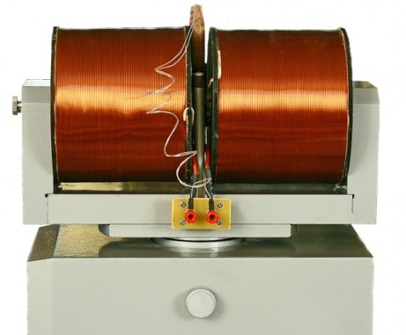
• Position the riders on the bench with the support rods at approximately the following separations:
Front of magnet yoke base – lens/polarizing filter: 15 cm
Lens/polarizing filter - interference filter: 6 cm
(as close as possible) Interference filter – étalon support table: 10 cm
Étalon support table - CCD camera – 15 cm
• Make sure that the lens in the lens/polarization filter combination faces the magnet.
• Filter has been changed. Turn either way Ignore this:The interference filter appears blue-green when viewed from

one side and yellow when viewed form the other.
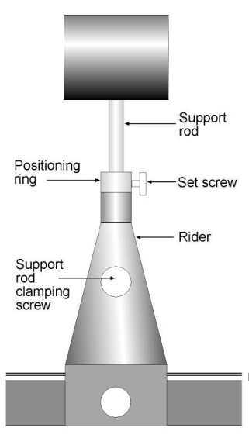
• Carefully adjust the heights of the lens/polarization filter, interference filter, and CCD camera so that their centers are aligned with the center of the mercury lamp and clamp them in place. Fix the adjusted heights with the positioning rings on the support rods (see Figure 6). This allows the optical elements to be easily removed and replaced accurately.

• As a rough guide for initial positioning, when the optical axes of the various elements are collinear and aligned with the lamp center, the bottoms of the positioning rings are at the following distances below the bottoms of their respective elements:

Lens/polarizing filter: 95 mm Interference filter: 97 mm Étalon table: 34 mm
CCD camera: 98 mm

•

Figure 6

• Place the Fabry-Pérot étalon on the support table, oriented with the three plate adjusting screws on the lamp side and the single tilt adjustment screw on the camera side. Make sure the étalon is centered on the optical axis and square to it. Do not adjust the plate adjustment screws.

•

6. Optimizing the Interference Pattern
The procedure for determining e/m involves measuring the diameters of concentric circles which differ only slightly. Precise adjustment of the optical setup to yield properly centered and undistorted circular fringes is important for obtaining an accurate result. To obtain a good interference pattern, attention should be paid to the following factors:

• Even illumination of the Fabry-Pérot étalon.

• Careful positioning of the various optical elements so they are centered along the optical axis of the setup and correctly aligned about their vertical axes.

• Precise parallelism of the Fabry-Pérot étalon mirrors.

• Optimal focus and aperture of the camera.

Even

Aligning the setup:

Check that the centers of the lamp, lens, filter, and étalon are collinear and that each element is its square to the optical axis. Adjust the position of the lens along the bench to maximize the size of the illuminated area of the étalon. View the étalon from the rear and adjust the position and height of the end of the bench so that the interference pattern is centered in the étalon mirror.

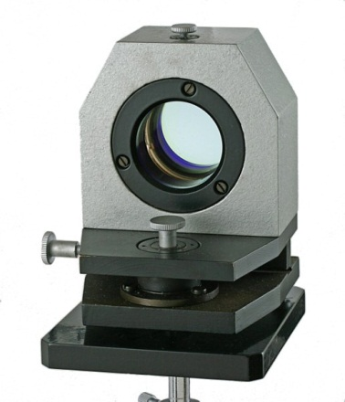

Adjusting the camera:

Replace the camera on the optical bench, connect it to an AC outlet, start the software and connect the camera to the software (see Appendix). Open up the iris with the aperture ring so that an image appears on the monitor. The Fabry-Pérot fringes are located at infinity, so the camera focus ring should be adjusted for distant viewing. The camera can now be moved along the bench as close to the back of the étalon as possible to exclude disturbing ambient light and increase the contrast in the monitor image. Optimize the image by adjusting the focus and aperture rings as necessary.

7. Recording the Patterns
Viewing the patterns—transverse viewing

Figure 9 shows the appearance of the patterns observed on the monitor for viewing transverse to the magnetic field in various states.

• Figure 9a shows the initial appearance of the pattern with no imposed magnetic field.

• Turn the potentiometer on the magnet power supply all the way counterclockwise, then press the ―MAGNET‖ button (Figure 10)

• Rotate the potentiometer clockwise to increase the magnet current until an easily-visible splitting of the circular fringes is seen on the monitor.

Note: Do not run the magnet with the potentiometer in the yellow zone (Figure 10) for long periods of time to avoid overheating the magnet coils.

• Rotate the polarizer mounted behind the lens until a pattern like Figure 9b is observed. This shows the full range of Zeeman- split lines emitted in the transverse direction.

• Continue to rotate the polarizer until the triple fringes shown in Figure 9c are seen. These are the strong π-polarized components that will be used for measurement.

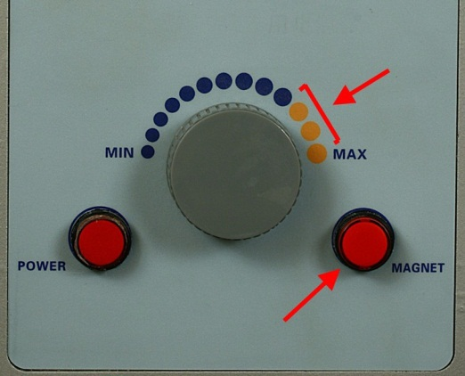
• Rotating the polarization filter by a further 90° yields the pattern shown in Figure 9d. These fringes arise from the σ- polarized components and are noticeably less intense.

Figure 10

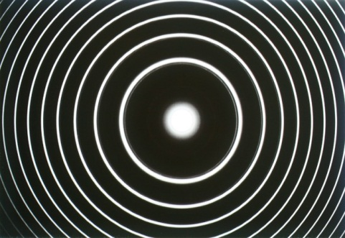
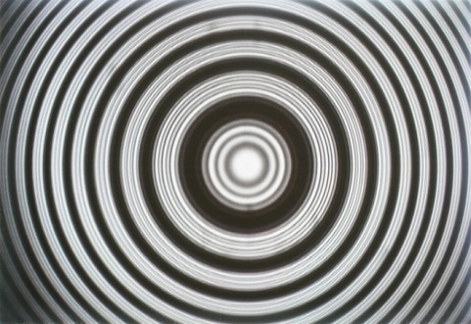
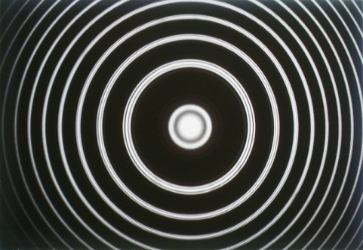
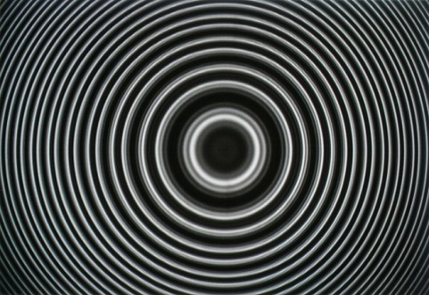
Figure 9a Figure 9b Figure 9c
Figure 9d

Saving the transverse pattern for analysis

• With the magnet set up for transverse viewing, adjust the polarizer to obtain a clear pattern of only the triple fringe set of the π-polarized emission as in Figure 9c.

• Adjust the magnet current to a suitable value to yield clearly separated fringes.

• Using a gaussmeter, measure the magnetic field strength at the location of the lamp.

• Note: The field strength can be obtained approximately from a field strength vs. current calibration curve, but a more accurate value is obtained by a direct measurement at the time the pattern is recorded. Carefully remove the lamp from its bracket to allow the gaussmeter probe to be inserted into the gap. BE CAREFUL NOT TO TOUCH THE BINDING POSTS OF THE LAMP POWER SUPPLY OR THE LAMP LEADS. Carefully re-insert
the lamp into its bracket after the measurement, making sure that it is inserted all the way until the shoulder rests on the bracket and that the window faces towards the optical bench.

• The Zeeman Effect software allows you to save the captured pattern in either BMP or JPG format. Select Action(A), then choose the appropriate ―Save As…‖ option for the format you prefer (see Figure 12). The standard Save As dialog box will appear. Navigate to the location where you want to save your patterns for measurement, name your file, and click on the Save box.

Figure 12

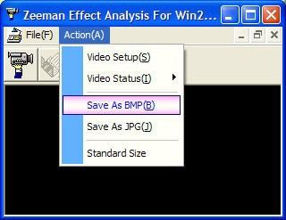

• 8. Analysis

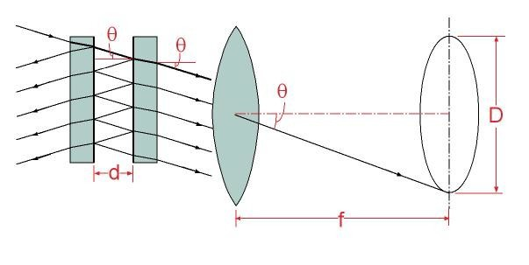
Figure 13

Figure 13 shows a schematic of the ray paths in the Fabry-Pérot étalon and the focused image at the camera.

The medium between the two mirrors is air with a refractive index of 1, so if the separation of the mirrors is d, the optical path difference between two adjacent light beams at an angle θ is

Δ = 2dcosθ.

For constructive interference with light of wavelength λ, Δ = kλ, and so

Δ = 2dcosθ = kλ

At the center of the pattern, θ = 0 and cosθ = 1. Since cosθ decreases with increasing angle from the center, the order of interference k is highest at the center of the pattern, and subsequent rings going outward are k-1, k-2, etc.

The rays exiting the étalon are parallel and when they are focused at a distance f from the camera lens, the incident angle θ is preserved.

The diameter D of an interference ring is 2f.tanθ (Figure 13)and for small values of θ at the center of the pattern, tanθ = θ so θ = D/2f. Approximating for cos θ at small angles, we obtain for the kth order ring
2 2
2d(1 - Dk /8f ) = kλ (1)

If the spectral line under study at frequency ν is produced by an electron transition between two energy levels E2 and E1, we have

hν = E2 - E1

In an external magnetic field B, the potential energy of magnetic dipole moment of an atom is:

ΔE = Mg.(eh/4πm).B (2)

where e and m are the charge and mass of the electron, h is Planck’s constant, M is the magnetic
quantum number and g is the Landé factor.

The additional potential energy shifts the energy levels E1 and E2 to E1 +ΔE1 and E2 +ΔE2 so the new frequency of the transition, ν’ is obtained from

hν’ = (E2 +ΔE2 ) - (E1 +ΔE1)

The shift Δν in the frequency of the line is

Δν = ν − ν’ = (1/h)(ΔE1 - ΔE2 )

Substituting for ΔE from equation (2) and converting from frequency to wavelength:
Δλ = (-λ2/c)Δν = (M2g2 - M1g1).(λ2/4πc).(e/m).B (3) From equation (1) we obtain for the wavelength shift in terms of the kth order ring:
2 2
Δλ = λ - λ’ = (Dk’2 - Dk ).(d/4f k) (4)
The effective value of f cannot easily be determined. To eliminate f, we introduce the (k-1)th
interference ring.

From equation (1):
2 2

Subtracting (1) from (5)
2d(1 - Dk-1 /8f ) = (k - 1)λ (5)

d/[4f2(Dk- 2
1

- D 2)] = λ (6)
k

Solving equation (6) for f2 and substituting into equation (4):

Δλ = (λ/k).(Dk’2 - D 2)/(D 2
k k-1

- D 2) (7)
k

For the rings close to the center, where cos θ ≈ 1, k ≈ 2d/λ. Substituting into (7) gives:
2 2 2

Δλ = (λ2/2d).(Dk’2 - Dk )/(Dk-1
- Dk ) (8)

Combining equations (3) and (8) and rearranging gives an expression for e/m in terms of measurable quantities:
2 2 2

e/m = (2πc/dB).[1/(M2g2 - M1g1)].(Dk’2 - Dk )/(Dk-1

9. Analysis of the saved pattern
- Dk ) (9)

Analysis is performed on the π-polarized triplet fringe set that corresponds to the transitions for which ΔM = 0. Table 2 details the magnetic quantum numbers and Landé factors for these transitions:

 | Upper State, 3S1 | Lower State, 5P2 | Δ
M | 1 | 1 | 0
 | 0 | 0 | 0
 | -1 | -1 | 0
g | 2 | 3/2 | n/a
Mg | 2 | 3/2 | -1/2
 | 0 | 0 | 0
 | -2 | -3/2 | +1/2
Table 2

Comparing the values of Δ(Mg) for these transitions with the corresponding term in equation (3), it is clear that the wavelength of the central fringe remains unshifted while the outer two are displaced symmetrically by an amount 1/2.(λ2/4πc).(e/m).B.

This allows us to use the diameters of two central lines in adjacent orders as Dk and Dk-1, and the diameters of the outer lines as Dk’ in equation (9) to determine e/m.

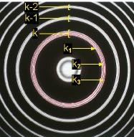
The software analyzes rings from three consecutive orders and averages to obtain values for e/m.

The designations used in the software for the ring diameters are shown in Figure 14. Error in figure: k3 is inner ring, k1 is outer ring.

With mouse clicks, the operator sets three points on each of three rings in three consecutive orders, and the software draws matching rings, identifies their diameters, and calculates the average differences of squares, then derives e/m.

The differences of squares displayed by the software are as follows:

Δd1 = (dk-12 - d 2
k

+ dk- 2
2

- dk- 2)/2
1

Figure 14

2 2 - d
2 + d
- d 2)/3

Δd21 = (dk12 - dk2
+ dk-11

k-12
2 k-21

k-22

2 2 2 - d
2 + d
2 - d
2)/3

Δd22 = (dk3
2
- dk2
2
+ dk-13
k-12
k-23
k-22
2 2

Δd1 corresponds to the term (Dk-1
- Dk ) in equation (9), while Δd21 and Δd22 correspond to (Dk’
- Dk )

for the Δ(Mg) = +1/2 and Δ(Mg) = -1/2 rings respectively.

Details of the installation and operation of the software are given in the Appendix.

Care of Apparatus

• The Zeeman Effect Apparatus should be used in a dry clean room with a good ventilation.
Cover the unit when it is not in use.

• Lubricate the surface of the optical bench periodically to prevent it from rusting.

• When not in use, the Fabry-Pérot étalon should be stored in a sealed container with a desiccator. Replace the desiccator periodically to prevent mold formation.

• Do it not touch any optical part with your hand. To remove dust or dirt, use a photographic lens brush, or blow the dust off with ―canned air‖. Do not use compressed air from an airline as this frequently contains oil droplets, which will contaminate the surface of the optical parts.Stubborn dirt may be removed by gently cleaning the surface with a cotton ball soaked in a 1:1 mixture of denatured alcohol and ether.

• To prolong the life of the mercury lamp avoid turning it on and off frequently.

• When applying the magnetic field, increase the current slowly and avoid leaving the potentiometer in the zone marked by yellow dots for long periods. This will avoid excessive heat generation in the magnet coils.

Connecting to the Video Capture Card

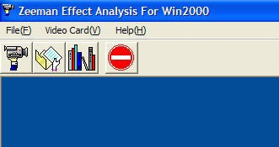
• Start up the software and instruct the software to connect to the video capture card by clicking on the camera icon or selecting Connect under the Video Card(V) menu.

Opening menus

• Generally, the software will not be correctly set up to recognize the video capture card and you
will receive the message ―Card don’t connect!‖. Click OK. The menu options will change.

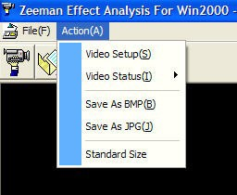
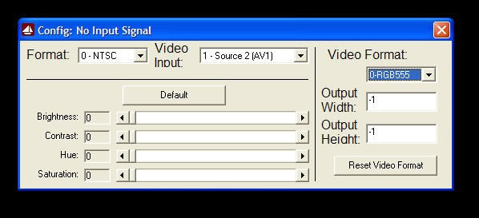
Video menu Video configuration dialog

• On the Action(A) menu select Video Setup(S). The video configuration dialog box will appear.

• Adjust the Format, Video Input and Video Format selections as follows: Format: 0 - NTSC
Video Input: 1 - Source x (AVx) (choose to match the card input where you connected the video cable during installation)

Video Format: 0-RGB555

Click Reset Video Format and close the dialog box.

• The image from the video camera should now appear on the monitor. The menu option Standard Size on the Action(A) menu sets the image on the monitor to the standard 640x480 pixels. The Video Status(I) option turns the live image on and off.

Recording an Image for Analysis

The procedure for adjusting the image and observing interference patterns is described in section 7 above. The software allows images to be saved in either BMP or JPG format. The software can analyze images in either format. The desired image is saved by selecting the appropriate option from the Action(A) menu.

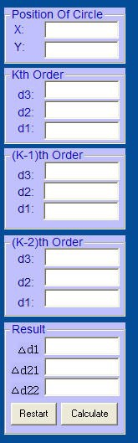
Procedure for Analyzing an Image

• If you are observing a live image on the monitor, select Close from the File(F)
menu.

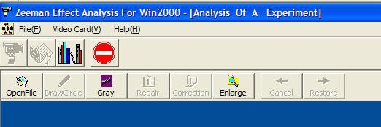
• Select Open File(O) from the File(F) menu, or click on the folder icon, then navigate to the location where you have stored in the file you wish to analyze. Open the file. The image appears together with a new menu bar and an empty results box.

Image analysis menus Results box

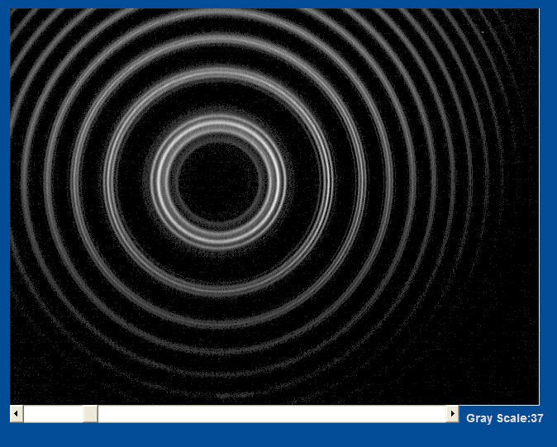
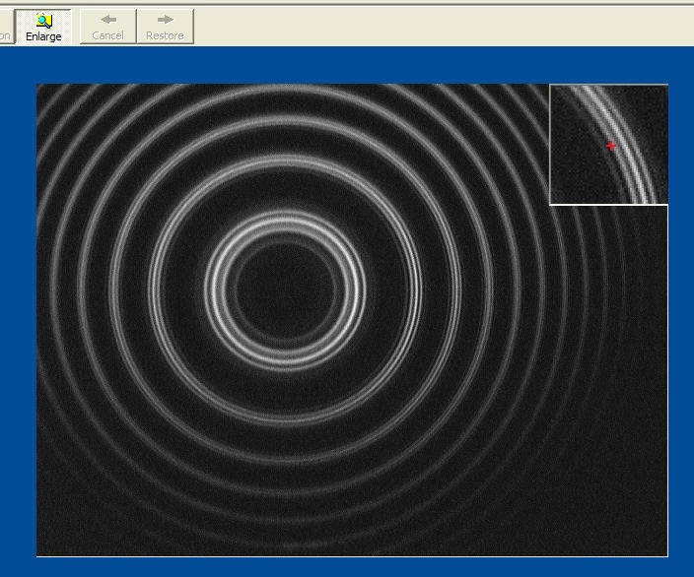
• The Gray icon initiates a function to improve the contrast in the image for easier analysis. A slider appears below the image. Adjust the slider until the contrast of the lines is optimal—all of the components should be clearly defined all the way around the circles.

The Gray function The Enlarge function

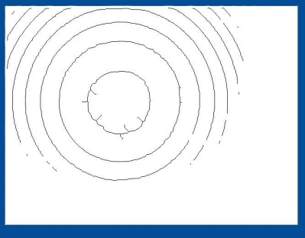
• The Enlarge function opens a subsidiary window in the top right corner of the image, showing a magnified view of the area around the position of the crosshairs. This is very useful in positioning the crosshairs precisely for measuring the positions of the rings.

• Repair function applies an algorithm to reduce noise in the image.
In most cases, it will not be necessary to use this function, since the contrast in the black-and-white image is usually sufficient, especially if ambient light has been excluded from the area between the étalon and the camera lens. If needed, the function should be used with
care as it is easy to render the image unusable by excessive repair
(see example).

Excessive repair
Analysis of an image requires the measurement of four sets of interference rings. In each set, each of the three components is located by placing locating crosshairs at three points approximately 120° apart on the rings. The first set of rings, most conveniently the innermost complete order, is used to establish the center point of the pattern. The remaining three sets establish the diameters of the components of the kth, (k-1)th, and (k-2)th order fringes.

• Locating crosshairs are placed on the image by left clicking the mouse after the main crosshair has been precisely placed on a ring. Erroneously placed crosshairs can be removed or restored by clicking the Cancel or Restore icon on the menu bar.

• After three crosshairs have been placed on a ring, click Draw Circle to calculate and draw the measured circle on the image.

• Carefully compare the position of the drawn circle with the image of the ring it represents. If the circle does not exactly coincide with the image, adjust its position and size to fit:

• The Page Up and Page Down keys increase and decrease the circle’s diameter respectively

• The Up, Down, Left and Right Arrow keys nudge the circle in their respective directions

• When all three components of the first set of fringes have been drawn, click the Correction icon
on the menu bar and answer No to the Hint question. The center of the circle system will be calculated
and marked by a crosshair and the center’s pixel coordinates will be entered into the results box.

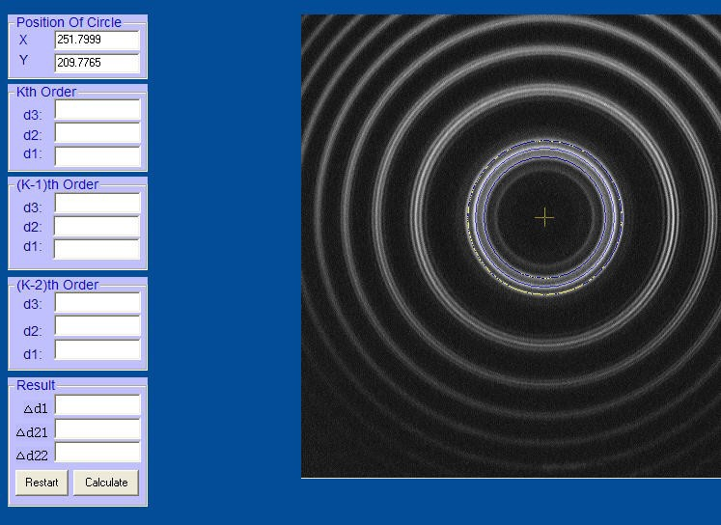
Center established

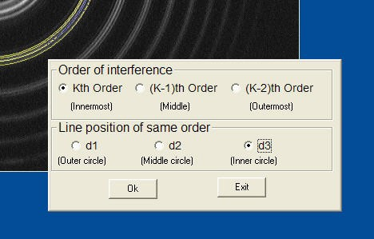
• Now proceed to mark out the first of the component rings of the kth interference order with locating crosshairs. After you select Draw Circle, a dialog box appears, asking you to identify which ring you are marking.

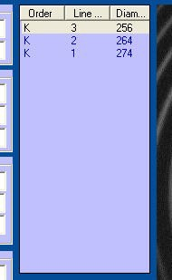
Ring identification dialog

• Make the appropriate selections for the order and line position and click Ok,
then Exit.

• A new box appears with the diameter of the line you have just measured and its identification entered.

• Proceed to measure the remaining lines of the kth order in the same way, then repeat the process for the (k-1)th and (k-2)th interference orders.

• When you are done, you should have all nine components of the three orders listed in the results sub-box.

Results sub-box

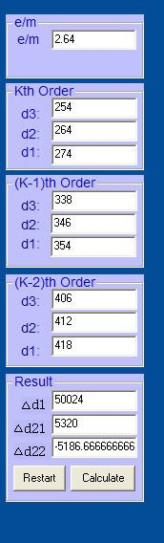
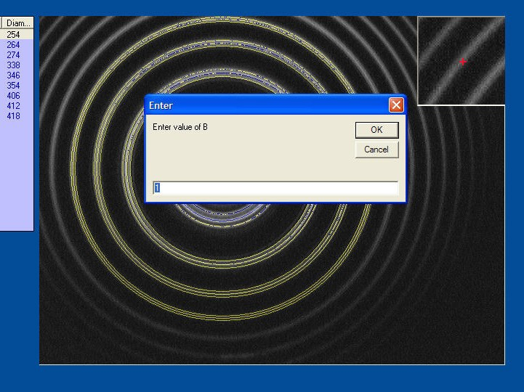
Field strength dialog
• Click on Calculate in the results box. A dialog box appears, asking you to enter the measured value of the magnetic field strength for this image. Enter the value in Tesla and click OK. The software performs the calculations and enters the results in the results box.

• To reset the software for a new and image analysis, click Restart in the results box.

• To exit the software, click Exit on the File(F) menu or select the Exit icon.

Viewing the patterns—parallel viewing

• Make sure the magnet current is turned off.

• Remove the iron core from the right hand pole piece of the magnet by pulling out on the thumbscrew (Figure 11a). This opens a narrow hole through the pole piece for parallel viewing.

• Rotate the lamp in its socket to direct the light from the window through the hole in the pole piece.

• Insert the quarter wave plate into the hole in the pole piece (Figure 11b)

• Release the magnet yoke arresting screw on the side of the magnet power sup- ply (Figure 11c) and swing the entire magnet assembly through 90° so that the light from the lamp is directed along the optical bench.

• View the pattern on the computer monitor. Adjust the angle of the magnet and the position of the optical bench as necessary to obtain as clear and bright a pattern as possible. (The beam is narrow and well collimated where it exits the pole piece, so this adjustment needs some care. You may need to adjust the position of the lens and/or the angle of the étalon housing to obtain the best image.) Tighten the magnet yoke arresting screw.

• Turn on the magnet and observe the pattern as before. The zero-field pattern splits into only two sets of fringes.

• Rotate the quarter wave plate and observe that each of the sets of fringes is extinguished once during a full revolution, confirming the circular polarization states listed in Table 1.

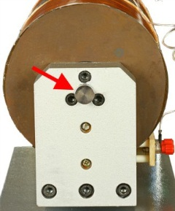
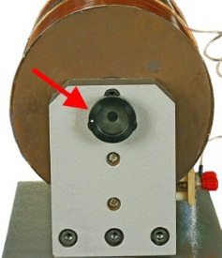
Figure 11a

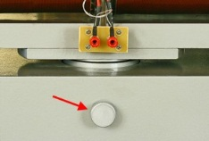
Figure 11b

Figure 11c

• Remove the quarter wave plate and observe that rotating the polarizer has no effect.

